**HCI Assignment Re-design**

**Chris Ahern Itm.**

**R00088097.**

Here is the re-design of the yahoo website based off this layout.



As I had addressed in my original analysis the problems I had pointed out were:

* The log in button changes on each page.
* The site is very cluttered.
* The homepage link is hidden.
* The site repeats itself.
* In some cases the load time between pages can take much longer than expected.

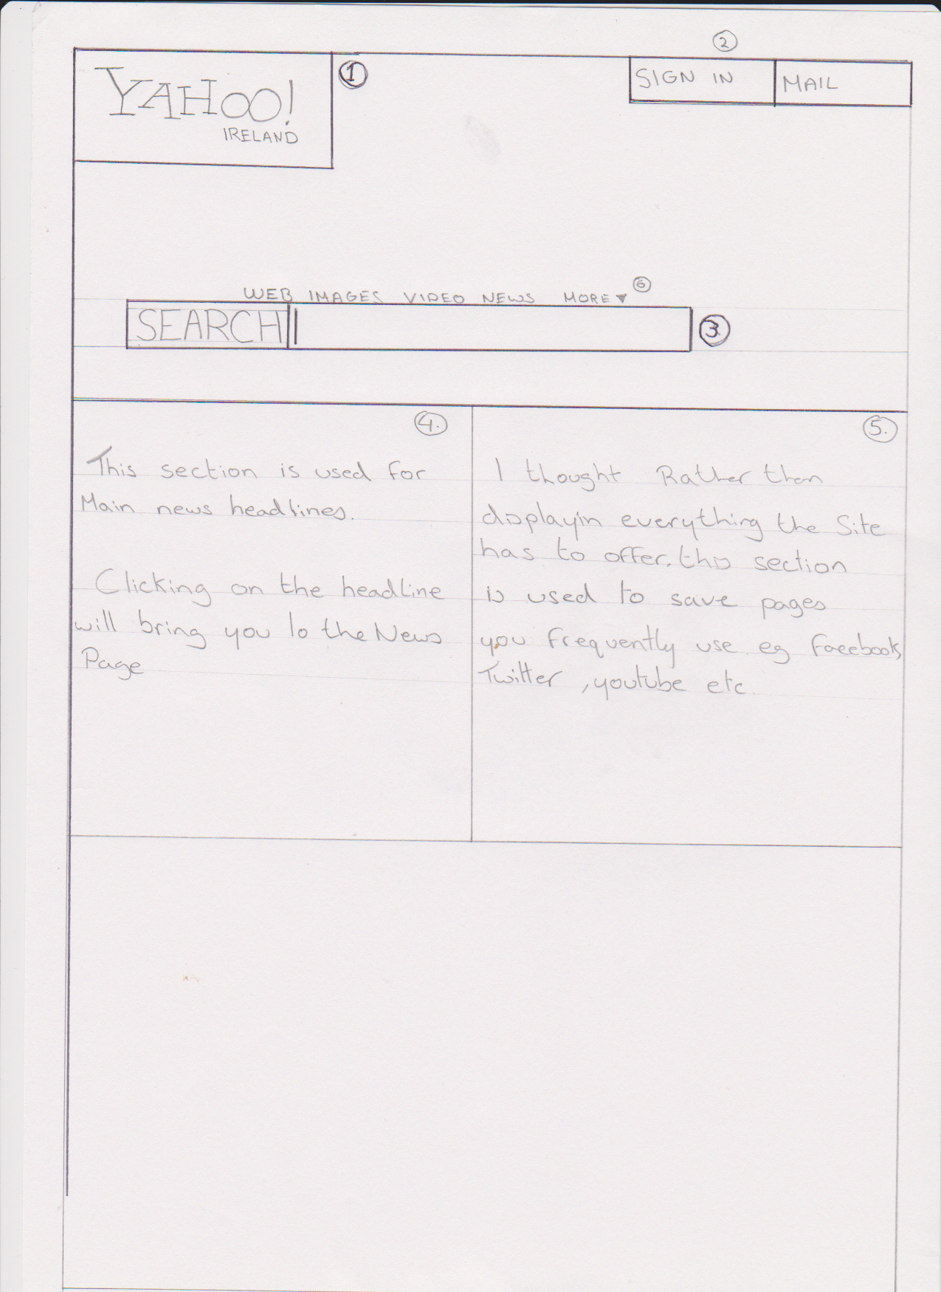

The problems I am addressing in this scan of my re-design.

1. The yahoo logo is now locked as the home page link, So whatever part of the site you are on once you click that it will bring you back here. As that yahoo logo brings you to the page you are already on. It makes no sense atall. The actual home button was a tine litle hidden button.
2. The sign in and mail buttons in the top right are locked into place, this avoids the issue I was having with them jumpoing around depending on which page I was on. Not only was that irritating it was confusing, new users would spend far to much time trying to figure out where it has dissapeared to.
3. Ive moved the search bar into the center for convienience. It just adds space and clears things up.
4. Rather than having all the clutter down the left hand side Ijust set a news section to show the top headline rather than lots of silly ones (Nicki Minage changed her hair colour....) Nobody needs to see the likes of this cluttering up their page.
5. On the left I decided it would be handy to have a quick access section for frequent pages. This will only be located on the homepage.
6. The “more” button has a dropdown menu with all the pages that were originally on the left hand side! This keeps them hidden and declutters the site.

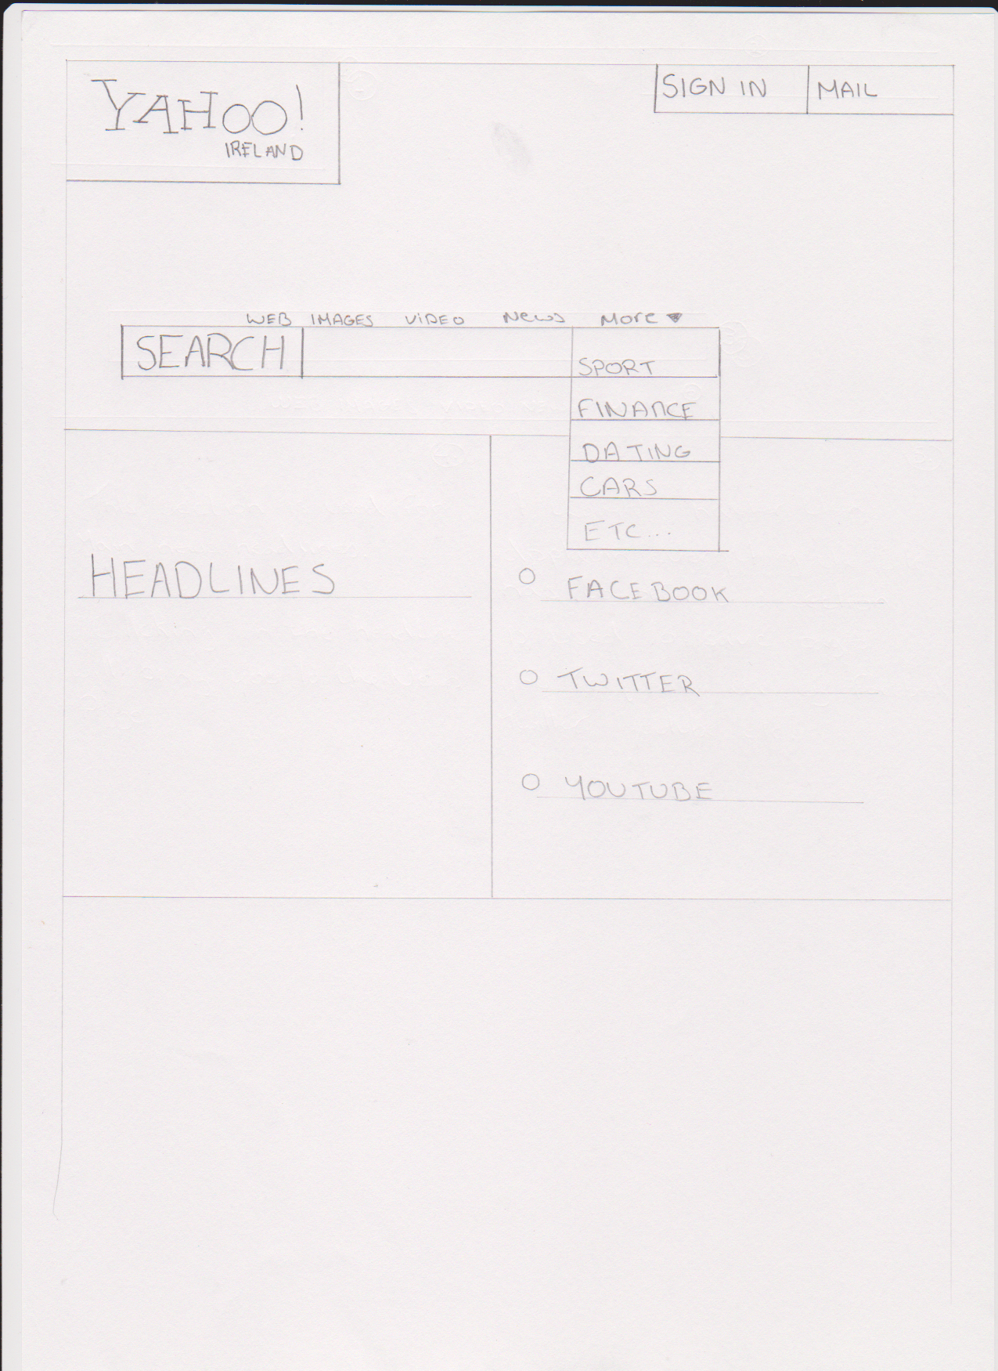

Here I have illustrated the dropdown menu and the quick links on the right.

I find these to be quite helpful especially if your homepage is set to be yahoo on your browser, there’s no searching to be done, just click and go!

Clicking on the news option above the search bar is to search for news headlines not to bring you to the news page.

I find if the site was kept in this layout and de cluttered if would have been easy to use from the start and would create less headaches. The site would also be consisten and easy to navigate.